**Admin Has The Power challenge Write Up**

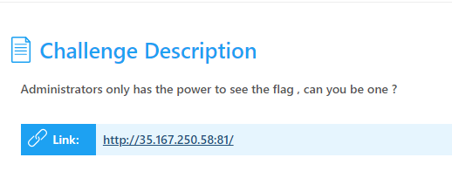

The link will take us to a login page

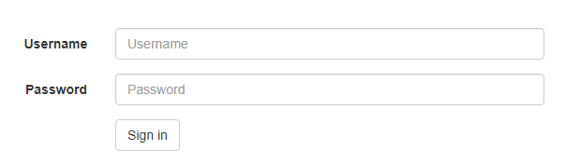

It’s asking for a username & password so we will check the source page if we can find anything that would be useful

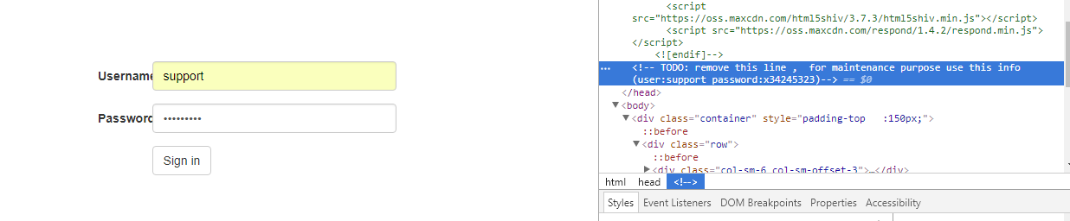

As we notice we will find a username &password written as a comment for support maintenance.

We will login successfully using this credentials but as you see it’s asking us to get a higher privilege

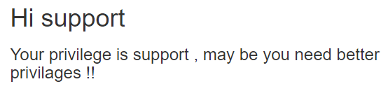

So we will intercept the data using Burp Suite

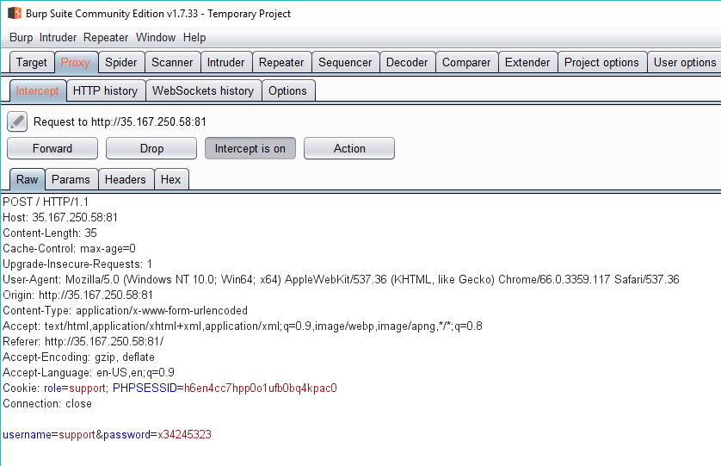

After the interception we will notice that the role mentioned as support so now we will forward the data after changing the role to Admin

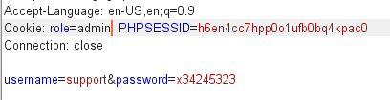

So let’s check the page again

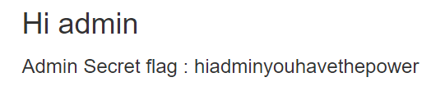

Now our role is admin and the flag is shown.